

**Software Requirements**

**Specification**

**For**

**Social Media Website**

**Version 1.1**

**Prepared by Stănescu Valentin Mihai**

**13.04.2017**

Table of Contents

Table of Contents 1

Revision History 2

1. Introduction 3

1.1 Purpose 3

1.2 Product Scope 3

1.3 Intended Audience and Reading Suggestions 3

1.4 Definitions, Acronyms, and Abbreviations 3

1.5 References 3

2. Overall Description 4

2.1 Product Perspective 4

2.2 Product Functions 5

2.3 User Classes and Characteristics 6

2.4 Operating Environment 6

2.5 Design and Implementation Constraints 6

2.6 User Documentation 7

2.7 Assumptions and Dependencies 7

3. External Interface Requirements 7

3.1 User Interfaces 7

3.2 Presentation Diagrams for the reviewing system: 8

3.3 Hardware Interfaces 17

3.4 Software Interfaces 17

3.5 Communications Interfaces 17

4. System Features 17

Functional requirements: 17

5. Other Nonfunctional Requirements 18

5.1 Performance Requirements 18

5.2 Safety Requirements 18

5.3 Security Requirements 18

5.4 Software Quality Attributes 18

5.5 Business Rules 18

6. Other Requirements 19

Appendix A: Glossary 19

Appendix B: Analysis Models 19

# Revision History

|  |  |  |  |
| --- | --- | --- | --- |
| **Name** | **Date** | **Comments** | **Version** |
|  |  |  |  |
|  |  |  |  |
| Stănescu Valentin Mihai | 20.03.2017 | First Revision | 1.0 |
| Stănescu Valentin Mihai | 13.04.2017 | Added More Button  Upload more images function  Media flag function  View count functionality on every post  Comment count functionality on every post  Rate count functionality on every post  Navigation menu on every post  Registered users can see their liked posts  Random post button  Notification mechanism comment | 1.1 |

# 1. Introduction

## 1.1 Purpose

The purpose of this document is to present a particularly description of a social media website. It will explain both the functional and non-functional features of the system, the external interfaces and what the system will do. For better understanding of specifications, there will, also, be provided: use case diagram, activity diagram, class diagrams and presentation pages for the reviewing system.

## 1.2 Product Scope

The scope of this project is to create and implement a web-application for an online variety of people. The website will be used by anyone who wants to enjoy sharing online content. The website will allow users to create and maintain individual accounts, search the Social Media Website database for post, and make new ones. The benefits of the application include: ease of access (on browser), responsive format for mobile devices.

## 1.3 Intended Audience and Reading Suggestions

This document is intended for both sides, the management staff and the developer of the system.

## 1.4 Definitions, Acronyms, and Abbreviations

Not Applicable

## 1.5 References

https://github.com/Valentin-Mihai/WAD-Project

# 2. Overall Description

## 2.1 Product Perspective

Social Media Website is an online platform and social media website. Users upload and share user-generated content or other content from external social media environment.

The Social Media Website application enables guests to browse and see all media, and system administrators to manage the proper functioning on the site.

**Use case diagram**

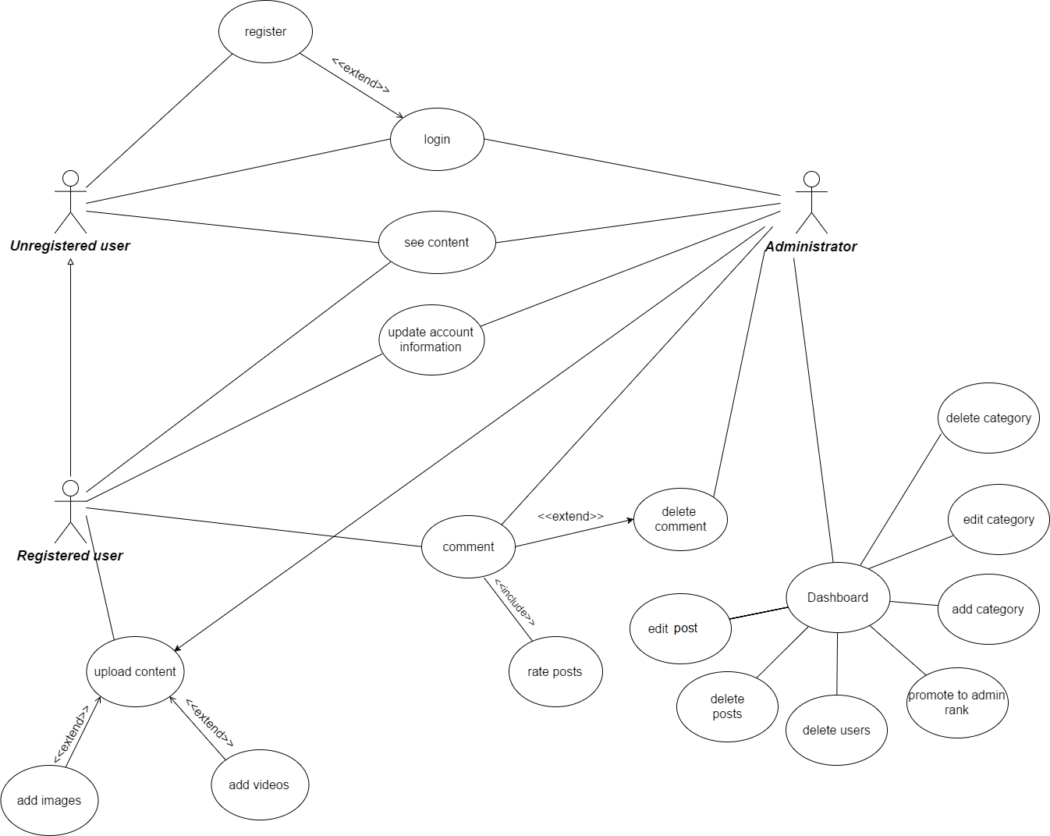

## 2.2 Product Functions

The primarily functionalities of the application will be:

* Sign up
* Log in
* Log Out
* Password recovery through E-mail
* Upload/Edit/Delete images and videos(with URL link)
* Leave comments
* Sort comments by date
* Sort content by date
* Thumbs up button
* Content distributed by categories
* Access to the content database
* Managing the database (admin only)
* Managing account details
* Bonus points- each user will receive points for uploading (1 point), posting comments (1 point) and log in (5 points)
* + Flag the post functionality

**Activity diagram**



**Class diagram for the reviewing system**



## 2.3 User Classes and Characteristics

There will be 3 types of user classes:

* Guest user: does not have an account, but can browse and see all media.
* Registered user: has an account, can upload/modify/delete his own content and comments
* Admin: has all power that registered user and guest has, plus he can manage the content and comments from the database.

## 2.4 Operating Environment

This application will be developed in: Net Beans Laravel framework (PHP, JSON), online [www.layoutit.com](http://www.layoutit.com) (Bootstrap, JavaScript, CSS and HTML).

Supported browsers: Google Chrome, Internet Explorer and Mozilla Firefox.

## 2.5 Design and Implementation Constraints

The default language will be English, the application should run correctly on any OS platform which contains a network connection and a web browser.

Backend language: PHP, JSON, XML

Frontend: HTML, CSS, JavaScript

Framework: Bootstrap

The application will be launched as freeware.

## 2.6 User Documentation

System Requirements Specifications document, System Design Specifications document and testing document.

## 2.7 Assumptions and Dependencies

It is assumed that the end user is connected to the Internet, since the application requires this.

When filling in a form, the users must respect the formatting options of each field, otherwise error/warning messages will be displayed and the action will not be fulfilled.

# 3. External Interface Requirements

## 3.1 User Interfaces

The interface is meant to be simple, fast and user friendly.

The application general layout will contain:

**The header which displays:**

* The logo of application
* Home button
* Categories button
* + More button
* Upload button
* Login
* Sign up
* Search bar
* View option
* + Random button
* + Notification mechanism comment

**The body:**

* Which displays content
* Special buttons that will make the connection with other social media websites
* Like button

**The footer with:**

* Copyright

**The guest user interface will contain:**

* A home button (which allows to return to the home page)
* A popular button (which allows to see the most popular content of the week/month)
* Categories button (contain a list with all the content categories)
* + More button (contain pages that a admin can add/modify/delete)
* Upload button (inaccessible if is not logged in)
* Login (the account)
* Sign up (make a new account)
* Search bar (search any desired post)
* View option (change the page viewing mode)
* + Post randomly chosen (choose a random post and displays it)
* + Notification mechanism comment (you will get a notice when someone has left a comment on your post)

**The registered user interface will contain:**

* It has a special field named My account where he can change his avatar or see his uploads on the site.

**The administrator interface will contain:**

* Has all power that registered user and guest has, plus he can manage the content and comments from the database through a Dashboard.

## 3.2 Presentation Diagrams for the reviewing system:

**HOME PAGE**

**C:\Users\Miky\AppData\Local\Microsoft\Windows\INetCache\Content.Word\Home.png**

**MEDIA PAGE**

**C:\Users\Miky\AppData\Local\Microsoft\Windows\INetCache\Content.Word\Media.png**

**UPLOAD PAGE**

**C:\Users\Miky\AppData\Local\Microsoft\Windows\INetCache\Content.Word\Upload.png**

**SIGN IN PAGE**

**C:\Users\Miky\AppData\Local\Microsoft\Windows\INetCache\Content.Word\Sign in.png**

**SIGN UP PAGE**

**C:\Users\Miky\AppData\Local\Microsoft\Windows\INetCache\Content.Word\Sign up.png**

**PASSWORD RESET PAGE**

**C:\Users\Miky\AppData\Local\Microsoft\Windows\INetCache\Content.Word\Password Reset.png**

**ADMIN PAGE**

**C:\Users\Miky\AppData\Local\Microsoft\Windows\INetCache\Content.Word\Admin Section.png**

**USER PROFILE PAGE**

C:\Users\Miky\AppData\Local\Microsoft\Windows\INetCache\Content.Word\My profile.png

## 3.3 Hardware Interfaces

Not applicable

## 3.4 Software Interfaces

The application is connected to a database which stores details about the user accounts, content, comments, categories and many others. There will be a communication interface between the server and the database (functions to read from and write into the database) and another one between the server and the client application.

## 3.5 Communications Interfaces

Transfer protocol used: HTTP

# 4. System Features

## Functional requirements:

* **Authentication**
* Sign up by completing form (username, email address, password)
  + Log in using user id or email and password
  + Forgot password option for resetting password, in case the user does not remember his password (email recovery)
* **View content on the website (unauthenticated users)**
* Search option for a specific post
* The possibility to see images and videos
* Change the view option (grid or list)
* Order the content by category (example: Animals, Comedy, Architecture)
* + Count the views on every post
* + Count the comments on every post
* + Count the likes on every post
* + post randomly chosen
* **Upload images and videos (authenticated users)**

Authenticated users have the same privileges as unauthenticated users plus:

* Upload media content on the website (images and videos)
* Leave a comment on a desired post
* Delete their own comments
* + Share a post on another social media website
* + See the total of post they liked
* + Navigate through a menu on every post
* + Upload several images at once
* + Flag every post they like
* + notification mechanism comment
* **Managing website (administrators only)**

Administrator users have the same privileges as authenticated users plus:

* Add and delete categories of posts
* Delete and edit media content
* Delete posts/users/comments
* Promote a user to be administrator
* + Add/modify/delete pages through the dashboard
* **Managing account details**

Both authenticated users and administrators will be allowed to change their personal account details (username, email address, update their picture, password).

* **Thumbs up the post**

Logged in users will be able to rate every post.

# 5. Other Nonfunctional Requirements

## 5.1 Performance Requirements

It depends on how fast is the server that host the application and on the internet connection speed.

## 5.2 Safety Requirements

Not applicable

## 5.3 Security Requirements

User accounts data will be encrypted. Only the admin can manage the system back end of the application.

## 5.4 Software Quality Attributes

1. Reliability: personal information (such as address) will be kept safe. The upload procedure will be safe.

2. Usability: The application is intended to be as simple as possible. The website will flow according to the user’s expectations.

3. Security: User accounts data and other electronic information will be handled as securely as possible.

4. Availability: The application will have “24/7” availability and it will be operational every day of the year.

## 5.5 Business Rules

Disclaimer: The purpose of this website, owned and operated by Social Media Website, is to provide web publishing services. By using or accessing the Services, you agree to become bound by all the terms and conditions of this Agreement. If you do not agree to all the terms and conditions of this Agreement, do not use the Services.

All rights reserved.

Images and copy on this website are for personal use only and cannot be reproduced commercially without permission.

# 6. Other Requirements

# Appendix A: Glossary

# Appendix B: Analysis Models

The strategy adopted for this project is the agile approach.